Zafra kamzi

Sap 56030

HCI lab-4

Mini Medical App

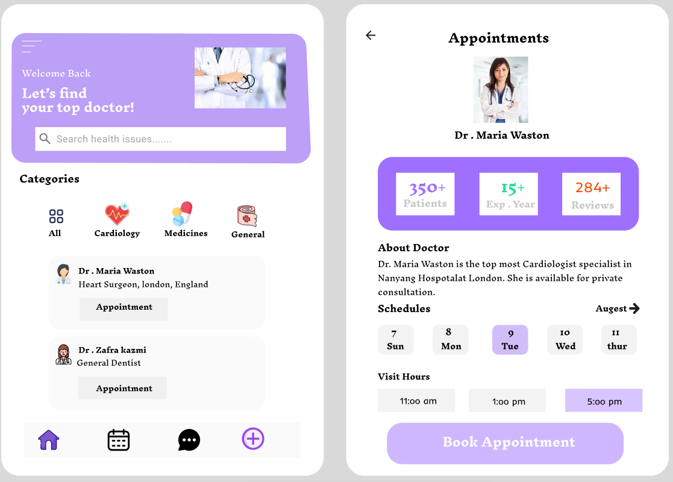

FIGMA LINK:

[Untitled – Figma](https://www.figma.com/design/wvKKcpECeK1a9Mepz7Or9L/Untitled?node-id=0-1&p=f&t=ytgD7QidKjunvgOQ-0)